envisioningclimatefutures.org
17 Mar 2026
Climate and Weather
What We Do
Our methodology
Modelling and visualizing floods
Modelling and visualizing wildfires
Examples
Flooding of the Don River (Toronto)
The Problem
A Proposed Solution
Visualizations
Little Etobicoke Creek flooding (Mississauga)
The Problem
A Proposed Solution
Visualizations
North Rustico flooding (Prince Edward Island)
Fort McMurray wildfire (Alberta)
Who We Are
Our Team
Partners
Sponsors

HOME PAGE
The movie on the top
Text below:
People have long been warned about environmental harm from greenhouse gases. We see devastation from floods, fires, and heat, yet citizens and governments have not acted sufficiently to slow climate change. Global surface temperatures and extreme weather events still increase dangerously.
Many climate communications are technical and despairing, causing fear and defensiveness. Others detail long lists of what people should do, causing confusion and indecision. Instead, we produce scientifically plausible future climate scenarios depicting what affects people the most — extreme weather. We create vivid and comprehensible messages and experiences portraying extreme weather. These begin with mathematically re-creating past weather events and then envisioning possible future variations of these events. Some futures depict the consequences of climate inaction. Others portray the constructive benefits of concrete and doable actions.

CLIMATE AND WEATHER
For over two centuries, scientists have been advancing our understanding of the effects of greenhouse gas emissions on the earth's climate. The levels of noxious greenhouse gases — carbon dioxide, methane, and nitrous oxide — continue to increase to dangerous levels; the rate of increase is also increasing. This is unprecedented and dangerous.
The most important reason for this is the continued burning of fossil fuels. Despite advances in renewable energy such as solar and wind technologies, fossil fuel use worldwide is still increasing. Forests and oceans have long countered the rise in atmospheric carbon dioxide by absorbing it. But the forests are disappearing due to human destruction and wildfires. The oceans are becoming acidified.
The result is planetary global warming, which is happening at a dangerous rate. There are many consequences to this. One dramatic result is that ice caps and glaciers at the poles are shrinking. Large chunks could soon be falling off, causing meters of sea level rise across the planet. Global warming also causes more extreme weather events such as hurricanes, typhoons, floods, heat waves, droughts, and wildfires. The number and intensity of such extreme weather events increase steadily, causing more death, destruction, homelessness, migration, and stress.
PIC: https://res.cloudinary.com/dd4p37hyq/image/upload/v1773722783/Impact_of_climate_change_on_extfreme_weather_Screenshot_sdci7q.png

https://www.carbonbrief.org/ https://www.worldweatherattribution.org/
Our research and this website document cases and methods for mobilizing individual and community action by demonstrating that inaction in the face of climate change will lead to more destruction from extreme weather, whereas there are doable actions that will make us safer.
OUR METHODOLOGY
VISION: To build computer simulation models of extreme weather events and then translate them into accessible images and experiences. To help individuals and communities a) better understand past extreme weather events; b) imagine how future damage could be worse if nothing is done; and c) see how constructive actions could reduce the damage from future storms. To produce constructive change in the behaviour of individuals and more thoughtful and open policy deliberations by government.
APPROACH: Well-designed images help people engage thoughtfully with critical issues. We therefore visualize extreme weather events — situations where climate change affects people most directly. Depictions of floods and fires show what neighborhoods have experienced, how damage could become worse, and how risks would be reduced if we act soon. What is novel is how we create experiences that portray the difference between action and inaction and use these to motivate and enable constructive change.
Our work integrates flood and fire modelling, data visualization, design, planning, and psychology. We develop novel visualizations and immersive environments. Unlike other work, and to maximize impact, images [LINKS TO THE EXAMPLE SECTIONS] are designed for lay audiences, portray local phenomena, are based on real data and validated models; are static and dynamic; and portray optimistic and pessimistic scenarios.
GOALS: To 1) create more immersive experiences (3D imagery, hypermedia, games, extended reality, lively exhibits); 2) speed up modelling and visualization processes; 3) demonstrate experimentally that these experiences affect the climate change engagement, understanding, and actions of individuals; and 4) deliver insightful experiences of actual or possible extreme weather to make citizen groups more knowledgeable; enrich schools curricula with learning units and games; and help government agencies charged with climate-related policy to conduct more thoughtful and open deliberations.

MODELLING AND VISUALIZING FLOODS
Our work proceeds as a series of case studies. The locations we study have experienced one or several instances of severe flooding and have gathered reliable data with which to calibrate and validate our models. The situations can be used to illustrate the difference in plausible future flooding based on the degree to which there is inaction (making future floods worse) or constructive actions (making the damage from future floods less severe).
This website reports on our first case studies, flooding at the mouth of the Don River (Toronto) LINK, and flooding of the Little Etobicoke Creek (Mississauga) LINK.
Past flooding is reproduced mathematically by modelling the flood in one of a set of computer systems for doing this. Thus far, we have used in our work both ESRI ARCGIS (link to https://www.esri.com/content/dam/esrisites/en-us/media/technical-papers/flood-simulation-arcgis-pro.pdf) and the U.S. Army's HEC-RAS (link to https://www.civilgeo.com/the-road-to-hec-ras/)
Data used as input to a flood model includes topography; land surface characteristics such as rivers and streams and dams and culverts; underground streams and drainage systems; and absorptive properties of structures on the ground such as building rooftops and parking lots. Models are driven by data on the water that comes from sources such as rainfall, tides, rising sea levels, and ocean surges. Models output descriptions of water flowing with varying velocities over landscapes over periods of time. If strong enough, these water flows are floods.
Once we can reproduce past flooding, we can use the model to imagine, project, and visualize future climate scenarios.
Climate change continues to pump more greenhouse gases into the atmosphere and increase the earth's surface temperature. Rainfall becomes worse because there is more moisture in the atmosphere. Storms become worse and more unpredictable because of greater numbers of events such as rainstorms, hurricanes, typhoons, and tsunamis.
On the other hand, concrete actions can be undertaken. Some actions affect the speed of climate change. These include decreasing our reliance on fossil fuels, increasing the use of electric vehicles, slowing the destruction of forests, substituting electronic communications for travel, and eating less meat. Other actions are specific to flood prevention. These include reengineering rivers and how they flow; increasing the capacity of drainage systems; constructing barriers to the flow of water such as dams and levees; and modifying the absorptive qualities of upstream land features.
We believe (and will gather evidence as one of our research activities) that such modelling and visualizing exercises will give people a greater sense of agency with respect to climate change and the vagaries of extreme weather, and will be a tool to enable more open, thoughtful, and constructive policy deliberations.

MODELLING AND VISUALIZING WILDFIRES
Coming soon ...

FLOODING OF THE DON RIVER (TORONTO)

THE PROBLEM
The Don River drains an area of about 1200 square kilometers in southern Ontario, falling about 250 meters in the 60 kilometers from its source as it makes its way into Lake Ontario. [IMAGE OF WATERSHED].
Heavy rainfalls often cause flooding. Major floods occurred in 1869, 1879, 1884, 1910, 1916, 1918, 1928, 1940, 1946, 1955, 1970, 1979, 1980, 1991, 2008, and 2024.
In 1886, the city of Toronto initiated the "Don River Improvement Plan". [LINK TO https://jenniferbonnell.com/books-publications/reclaiming-the-don/] Concerns that led to this Plan were threefold: public health dangers from urban wastes including sewage in the river, damage from floods, and impediments to Lake Ontario shipping from silt build-up erroneously attributed to the river. The plan was to widen and deepen and straighten the river channel in the last 2 kilometers before it reached the lake. Additional benefits from the plan were intended to be allowing ships to come up the river and railroad tracks on both banks of the river.
The project suffered from cost overruns, technical missteps, political controversies, and a gradual weakening of its specifications. Most of its goals were not achieved. The final mistake was to build the Keating Channel, which forced the river to make a 90-degree turn as it approached the lake. [IMAGES OF KEATING CHANNEL] Furthermore, the Channel was completed in 1922 at less than a third of the desired width. The right turn guaranteed that the industrial lands that were just south of the Keating Channel would also suffer from even worse flooding than before.

A PROPOSED SOLUTION
In 1989, over 500 people attended a public meeting with the city of Toronto and the Toronto and Region Conversation Authority (TRCA) to discuss ways to clean up the Don watershed (https://www.waterfrontoronto.ca/news/bringing-back-don-30-years-citizen-advocacy). The TRCA was an organization set up by the province and then given enhanced powers after 81 people died during the 1954 flooding of the Humber River caused by Hurricane Hazel. LINK
After years of discussion and planning, Waterfront Toronto announced In February 2007 an international design competition to finally solve the problem of flooding at the mouth of the Don [Mouth of Don IMAGE, Flyover IMAGE], to create a major new park and space to house 15,000 people free of flooding [3 Ookwemin Minising IMAGES], and to do all of this by re-engineering the mouth of the Don. (https://www.waterfrontoronto.ca/our-projects/don-mouth-naturalization-and-port-lands-flood-protection, https://housing-infrastructure.canada.ca/alt-format/pdf/eval/2021-2-eval-twri-plfp-pt-eng.pdf, https://www.mvvainc.com/projects/port-lands-flood-protection)

VISUALIZATIONS
We have generated portrayals of real floods and plausible scenarios predicted by flood models. The figure portrays 10-, 100-, and 350-year (their "return periods" — measures of intensity) floods before and after the Don River mouth reconstruction completed in 2025. The Port Lands at the mouth of the river can now withstand major storms. There is still flooding to the east, which is being addressed by a subsequent flood mitigation project now underway (https://trcaca.s3.ca-central-1.amazonaws.com/app/uploads/2021/09/17175237/BEFP-Final-Class-EA-Report-August-2021_with-exec-summary.pdf).

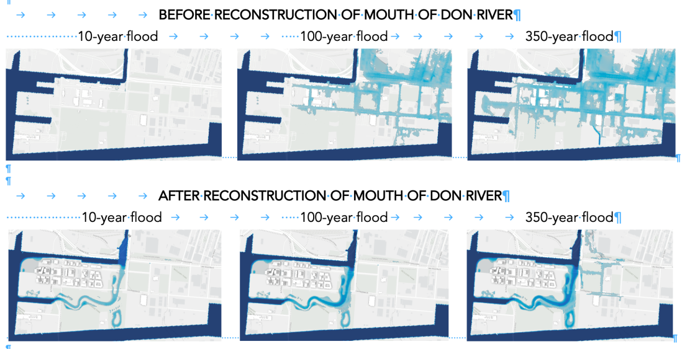

FLOODING OF LITTLE ETOBICOKE CREEK (MISSISSAUGA)

THE PROBLEM

The Little Etobicoke Creek (LEC), a tributary of Etobicoke Creek, winds its way southwards in central Mississauga from just west of Toronto Pearson International Airport to Lake Ontario. LEC-MAP-PIC

Decades ago, much of the water from severe rainstorms in Mississauga was absorbed by farm in the north part of the city. Now, these absorptive materials have been replaced by homes, factories, stores, and parking lots. And storms have become more severe due to climate change. Floods are occurring more often, and they do more damage, for example, in 2005, 2009, 2013, and 2024.

The 2013 flood and two floods in 2024 floods of Little Etobicoke Creek were particularly destructive.
METRO-TO-STORM-PIC
2024-STORM-RAINFALL-PIC
LEC-LANDSCAPE-PIC
2013-FLOODING-LEC-PIC
OBLIQUE-VIEW-LEC-FLOOD-PIC
LEC-2D-FLOODING-VIDEO
LEC-3D-FLOODING-VIDEO

https://thepointer.com/article/2024-07-29/11-years-2-destructive-floods-millions-in-damages-why-hasn-t-mississauga-moved-quicker-to-protect-residents

https://www.mississauga.com/news/council/start-the-project-immediately-mississauga-residents-push-city-to-speed-up-80m-stormwater-plan-after/article_f21a06a6-916f-594a-b2d3-86df8b66bb82.html.
A PROPOSED SOLUTION
In response to the flooding, the city of Mississauga commissioned several studies and held public meetings to report on the results. Coincidentally, the final report was published in May 2024, soon before the 2024 floods.

The report recommended close to $80M worth of improvements including widening and deepening the creek near where it tends to flood as it makes a critical turn near Queen Frederica Drive, and also replacing the nearby bridge over Dixie Road with a greater span and with larger culverts that will allow more water to flow through.
DIXIE-AREA-PROPOSAL-PIC
https://www.mississauga.ca/wp-content/uploads/2023/05/Dixie-Dundas_PIC-2_FINAL.pdf#:~:text=The%20Dixie%2DDundas%20Flood%20Mitigation%20Feasibility,to%20protect%20existing%20residences%20and
https://www.mississauga.ca/wp-content/uploads/2024/06/19152312/dixie-dundas-flood-mitigation-environmental-assessment-study.pdf.

VISUALIZATIONS
We have re-created and visualized the 2013 and 2024 LEC floods, focusing on the area near Queen Frederika Drive, Dixie Road, and just south of there.
Below we show how damage varies with the storm intensity (top: 10-year storm; below: 100- and 350-year storms); and how effects could be reduced by what engineers have recommended — the riverbed channel deepening and widening; and replacing a bridge with one that has larger culverts and so is better able to support greater flow to the east. What is interesting is that neither expanding the river channel nor replacing the bridge succeed in mitigating the damage if done by themselves.

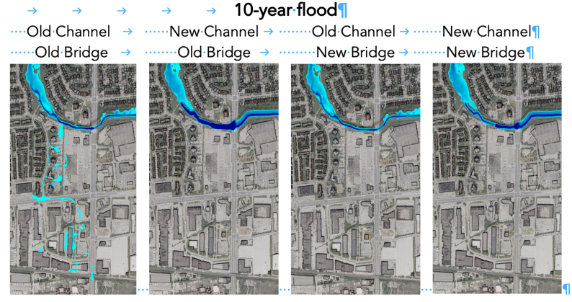
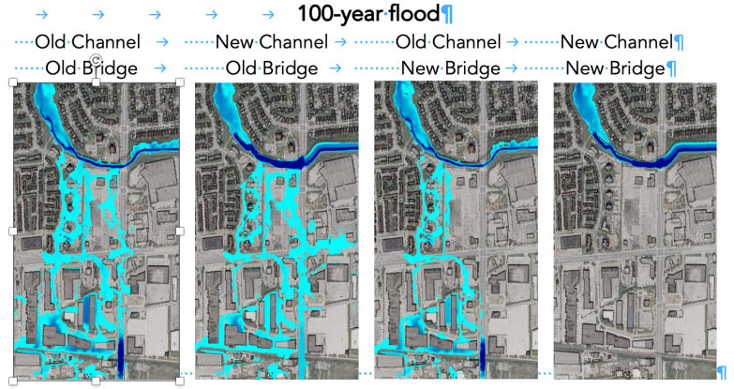
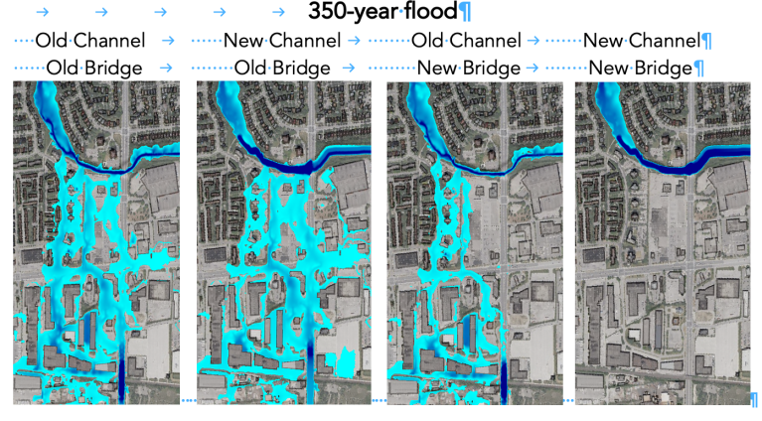
WHO WE ARE
OUR TEAM
You have completed this.

PARTNERS
Links to Dynamic Graphics Project, Department of Cities, and School of Cities, UofT; Climate Smart Lab, UPEI; Departments of Psychology, VIU and University of Victoria; Ontario College of Art and Design

SPONSORS
Holgan 8T8 Foundation; Department of Computer Science, University of Toronto; School of Cities, University of Toronto; William T. Reeves and Ricki Blau; John Baker; Kim Davidson; SideFX

